Project Design Phase-II
Data Flow Diagram & User Stories

Date | 3rd October 2026
Team ID | SWTID-2026-3114
Project Name | Implement Client Script & UI Policy (Incident)
Maximum Marks | 4 Marks

Data Flow Diagram:

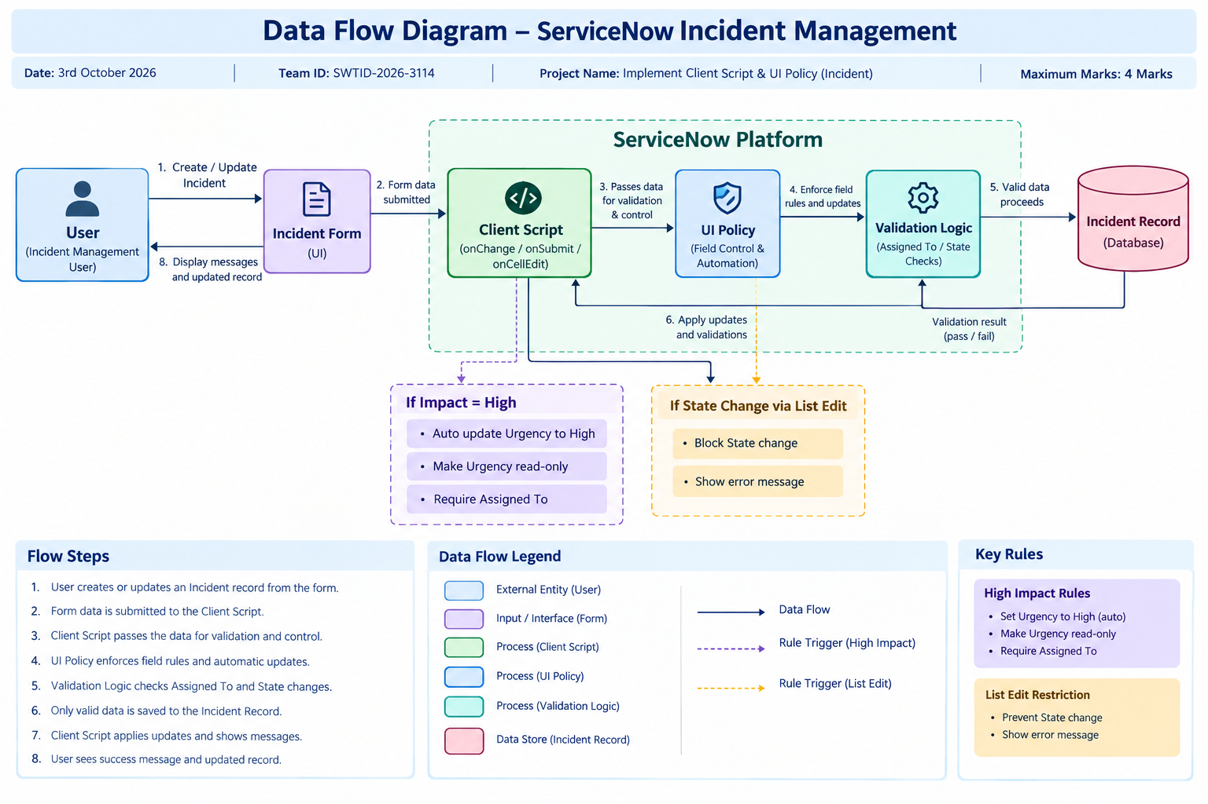

User Stories:

User Type | Functional Requirement (Epic) | User Story Number | User Story / Task | Acceptance Criteria | Priority | Release
Incident User | Incident Field Control | USN-1 | As an Incident user, I can set the Impact of an Incident so that the system can apply the appropriate field controls. | When Impact is set to High, the High Impact UI Policy is triggered. | High | Sprint-1
Incident User | Automatic Urgency Update | USN-2 | As an Incident user, I want Urgency to be automatically set to High when Impact is High. | When Impact is set to High, Urgency is automatically set to High and an information message is displayed. | High | Sprint-1
Incident User | Urgency Field Control | USN-3 | As an Incident user, I want the Urgency field to become read-only for High Impact Incidents. | Urgency cannot be manually changed when Impact is High. | High | Sprint-1
Incident User | Assigned To Validation | USN-4 | As an Incident user, I want the system to validate the Assigned To field before saving a High Impact Incident. | The record cannot be saved when Impact is High and Assigned To is empty, and an error message is displayed. | High | Sprint-1
Incident User | Reverse Condition | USN-5 | As an Incident user, I want field controls to revert when the High Impact condition is no longer true. | When Impact is changed from High to another value, the UI Policy changes are reversed. | Medium | Sprint-1
Incident User | State Change Restriction | USN-6 | As an Incident user, I want to prevent State changes through direct list editing. | Editing State from the Incident list is blocked and a warning message is displayed. | High | Sprint-2
Incident User | Incident Update | USN-7 | As an Incident user, I want to update an Incident through the form so that valid changes can be saved. | Valid Incident updates are successfully saved through the Incident form. | High | Sprint-2
Administrator | Configuration Management | USN-8 | As a ServiceNow administrator, I can configure Client Scripts and UI Policies to control Incident form behavior. | Active Client Scripts and UI Policies execute according to their configured conditions. | High | Sprint-2
Administrator | Testing & Validation | USN-9 | As a ServiceNow administrator, I can test the configured controls under different Incident conditions. | Mandatory enforcement, successful save, reverse condition, list edit blocking, and form-based updates work as expected. | Medium | Sprint-2

